Parma FFA Chapter Jacket Scholarship
Up to $35.00, Including Scarf or Tie

Name: _____________________________________________________
Ag Class: __________________________________________________
Year in FFA: ______________
Home High School: _____________________________________
Jacket Information
Arm Length: ____________________
Back Waist Length: ______________
Chest/Bust: _____________________
High Hip/Seat: ___________________
Shoulders: ______________________
Waist: __________________________
Jacket Size: _____________________
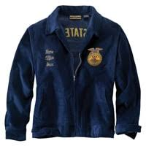
Use this website to help you calculate your exact jacket size.
https://www.ffa.org/jacket-measuring-videos-calculator/

Please thoroughly answer the following questions:
1. List your future goals in the FFA.
________________________________________________________________________________________________________________________________________________________________________________________________________________________________________________________________________
2. List your activities in school and community.
________________________________________________________________________________________________________________________________________________________________________________________________________________________________________________________________________3. What does your S.A.E. project consist of at the present time, and what are your future plans?
________________________________________________________________________________________________________________________________________________________________________________________________________________________________________________________________________
4. What do you wish to gain from receiving this award?
________________________________________________________________________________________________________________________________________________________________________________________________________________________________________________________________________
5. How can you benefit yourself and the FFA Chapter by receiving this scholarship and jacket?
________________________________________________________________________________________________________________________________________________________________________________________________________________________________________________________________________

